TDSB SEAC Report
Samantha Currie & Jacob Klugsberg
April 10, 2018

EXECUTIVE SUMMARY

The Special Education Advisory Committee (SEAC) of the Toronto District School Board (TDSB) conducted an extensive survey of the parents of children with special education needs enrolled in TDSB schools. The following report details the results of this survey, highlighting the challenges faced by children with special education needs and presenting some ideas for addressing their concerns. With responses from over 1600 parents, the information in the results carries substantial validity and weight. This report is based on responses received up to and including February 13, 2018.

The survey was divided into five main sections, focusing on the overall concerns and recommendations of parents, the particular needs of the students, the experiences of parents with the TDSB, feedback on the Individual Education Plan (IEP), and an evaluation of the Identification Placement Review Committee (IPRC) and Special Education Placement Review Committee (SEPRC).

SECTION A: PARENT RECOMMENDATIONS

General Trends

From the onset, the first question in the survey (Q1) gives parents the opportunity to provide recommendations on the TDSB’s efforts to meet the needs of special education students. From an analysis, there are five themes that sum up the majority of those recommendations provided. First, parents feel that the TDSB needs to take a more proactive approach to identification and accommodation. Second, that the TDSB needs to promote and help facilitate better dialogue; between both teachers and parents, and parents and administrative decision makers. Third, that the TDSB needs to increase the number of education professionals within the classroom and to the committees that process assessments. Fourth, that education professionals must undergo more rigorous training and work towards implementing new learning techniques and technologies in the classroom. Fifth, parents feel as though better delineation of procedures, possibly online, would help parents successfully navigate the programs and accommodations offered.

1. The TDSB Must Adopt a More Proactive Approach

The cumulative responses revealed that many parents were displeased with the efficiency of the identification and assessment process currently in operation. These parents feel as though assessments should be conducted earlier in a child’s educational journey.

“Intervention for a student entering a new grade should take place immediately, if the child is already identified with a diagnosis. When my child entered JK, we knew he’d need extra help, but nothing (no special provisions) happened for the first month, except difficulties that we could have predicted.”

“Elementary schools need to do a better job of identifying students with special needs and supporting early intervention.”

“Early identification. My son was very clearly showing signs of a learning disability yet the school was unwilling to test him because he was only in Grade 1. While I recognized there is a HUGE range on when children learn to read etc, however, the school didn't even notice he couldn't recognize letters of the alphabet when they were out of order. He had a miserable year with a teacher who was frustrated with him and who felt like he wasn't trying. I asked the school multiple times if he should be tested for a learning issue. I was told, "it wasn't time for that yet". I had him privately tested over the summer (at the considerable expense that really should have been done by the school board) so that his issue could be identified and he could start Grade 2 off on the right foot. I am lucky I had the resources to do this. I feel for the parents who don't and risk their children falling even further behind.”

“Earlier identification would have been very helpful. Our principal pegged our daughter as gifted as early as Grade 1. She was supposed to have been tested in Grade 3 but that teacher decided he didn't see any reasons for the testing so cancelled it without consulting us (we were furious!!). She was tested in Grade 4 but we were assured her school could accommodate her in mainstream classes. By Grade 6, she was bored, unmotivated, and not relating to her peers. She went into a gifted program for Grade 7 and the change was incredible! She loved the kids, loved school! Finally felt like she belonged. She was engaged and interested in her classes. We're sorry we didn't put her into a gifted program from Grade 5 onwards. It is integral to her success in school now that she is in Grade 9.”

“More proactive solutions, more EA availability, more collaboration with parents instead of intimidation and ignoring recommendations.”

“Identification is important. My son has been identified since early grade school and the only assessments he has had have been the ones we have done outside the schools. He has been with tdsb for high school only and is on a wait list for an update to his assessment.”

“We had to start school before the TDSB would review our documents, diagnosis and recommendations from doctors. It took 6 months for our Son to be placed in the right class, time which could have been saved if the IPRC process could start prior to a student starting school. IEP's - Teachers in Spec Ed are not taught how to write these. Please make training mandatory for those responsible for Spec Ed Classes. Options/ Adaptions available for students are not provided for parents. Parents need to look, search, find and fight for resources in the class or variances to the norm to be asked for. Please provide a list or resource for parents. The process for getting a service animal into a TDSB school is not standardized and if it is, it has not been communicated with schools (principals). Please educate the administration.”

2. Better Dialogue Between TDSB and Parents

Many of the responses show that parents are displeased with both the quality and frequency of their communications with TDSB actors. These parents feel as though more frequent reporting and consultation opportunities with should be mandated of teachers, so that parents have a more complete understanding of the overall progress being made in the classroom. They believe this will better allow them to foster the growth and development of their children outside the classroom. Some noted that use of technologies, such as email and virtual information sharing platforms, could make it much easier for parents to feel involved and remain informed. In addition to concerns around frequency, parents are also dissatisfied with the quality and character of the conversations had with teachers. Parents feel that teachers fail to empathize with the struggles of the parents themselves. They wish that teachers would be more sensitive in their delivery of information and addressing of parents’ questions and concerns. Additionally, many found that there is an excessive use of ‘jargon’ which is further convoluting. In their responses many assert that this makes navigation of an already complex process more difficult and intimidating.

“They can be extremely stressful and overwhelming experiences for parents/guardians and the TDSB needs to always remember that!”

“Better communication between parents, teachers, school staff and students. Clear protocols distributed to parents and affected students. Websites should clearly indicate how to transfer IEP from different schools, or boards.”

“We've felt really in the dark the last 3 years, trying to navigate the system for our son. When we finally get information, it's very last minute and we have to make quick decisions that we don't feel prepared for. Other parents we talk to feel the same way. I recommend you make resources publicly available that tell parents what the process is to have a child classified and recommendations made for special needs placements, whether gifted, behavioral, learning disabilities, physical or emotional disabilities, religious accommodations, etc. And more importantly, teach educators about these resources so they can point parents to them. Simply knowing what Assessments, meetings, paperwork and possible placements are available would ease a great deal of anxiety.”

“Getting the teacher understand that parent want the best and want their child to succeed and teachers shouldn’t consider the special needs kids as burden on them. Teachers make hideous comments and insensitive comments to parents when they one to one with the parents as they know they don’t want to get themselves in trouble by making these comments in the group. At the SST or other group meetings these teachers will appear as saints. Bottom line: they don’t want to work hard and they see special needs kids as bane of their existence.”

“The process and paperwork is confusing and repetitive. However I appreciate the process and the work being done. I wish there was more information explaining what different terms mean and less complicated language was used in the documents.”
“Improve communication with parents IEP needs to become more used to guide teachers, all teachers involved with a child should be aware of a child’s issues without a parent having to facilitate it. Make the process for assessment more transparent and less intimidating. Teachers in the local school should communicate better with families about what an IPRC etc is. As an educated Canadian born person I found it difficult to navigate and somewhat intimidating. I can only imagine for someone without education or not English speaking how difficult it must be. Support for gifted students is laughable; at the elementary level there should be some sort of enrichment available at the home school.”

“Better communication between the parents and the special education teachers. That starts with better education of parents of specials children to understand and navigate the system and be aware of what resources are available to them [i.e. social worker, psychologist, etc] Do away with all the acronyms and abbreviations. Have a clear process in place on what the next steps should be and who this the contact person.”

“I feel they are very insensitive to parents and students with Gifted exceptionality. Their comments are at times offensive and they don't feel the students should be in Gifted classrooms. They don't understand the parents of special education students and are making "rules" based on their desire to cut down special education classrooms.”

“We have a child with ADHD, Autism and LD. As parents we always felt like left out. We wanted to be more involved in our child's education. We were telling his teachers to send little notes home about what he is struggling with or anything that was going on with him but be got nothing. They never focused on his strengths but only on his weaknesses. Therefore, our child was not feeling valuable and did not believe in himself. It takes only little encouragement to help anyone to feel better about himself. Now our child is in LD class and we feel so lucky to that his teacher is so helpful and we have a good communication with her.”

“Ensure all schools and teachers understand that accommodations should not be something that parents and students feel badly or bothersome about asking for. Accommodations level the playing field they do not tip the scales. If we wonder why there is a stigma associated with special ed - we often don't have to look too much further than our own instructional leaders.”

“1) Provide meaningful parent and expert consultation as part of the needs assessment process. Currently, the decisions are made prior to parent involvement and all meetings with the parents are solely to placate parents. 2) Provide more transparent communication about the process for getting help and make sure parents know their rights 3) Provide a meaningful process to get help with actual deadlines for delivery, not just deadlines for responses 4) Provide a non-adversarial appeals process that focuses on the needs of the children and not the policies and practices of the board 5) Develop public written policies that address special needs decisions that actually follow the Ministry of Education direction and do not limit child qualification.”

3. Resource Based Concerns

The responses overwhelmingly demonstrated that majority of parents have concerns regarding funding and resource allocation in special education programs. Predominantly, parents feel as though there need to be more favourable student-to-educator ratios (teachers, educational assistants, occupational therapists, counsellors). Correspondingly, parents would like to see more resources directed towards the identification of learning disabilities as well as the rigor of assessment and expediency of training for educators.

“Shorter wait lists. Every referral takes years to be assessed and in the meantime your child is lingering between and behind.”

Teachers trained with a special degree in specialized education so that they understand the needs and capabilities of each child. A teacher should have a mandatory teacher helper in each class who also is trained with a specialized degree. Every 3 months a teacher/parent interview to ensure needs of the child are being met. There should be a lead supervisor in attendance too to make sure goals are met.

"I believe that the reality is that the TDSB needs more educational assistants, teachers and professionals in the schools. Unfortunately, classrooms are filled with children of various needs and it’s impossible to expect a single teacher to address every individual child. Congregated gifted classrooms and the Home School program are helpful ways to start addressing the overwhelming need”

“Obviously have more resources available to assess students earlier and more accurately within the board--it is prohibitively expensive to have assessments done privately and the majority of families don't have adequate benefits Please make sure teachers know how to read and create IEPs and interpret them--it is unwieldy how many there are in a given class, but teachers need support to be able to deliver what kids need individually to the best of their ability, understanding that it is impossible to meet every criteria every or all of the time Educate parents better about what acronyms mean, what their rights are, and above all how to seek assistance when their child experiences difficulty BEFORE it becomes a crisis--if parents had support at this juncture it would make everyone's life/job easier: parents, kids, teachers, admin, principals, school spec ed departments etc--the TDSB is required to teach my child and everyone else's--why wouldn't you foster an team environment so that ultimately the kid has the best chance of success? It does happen, it just needs to happen more often, more consistently and more accessibly...get the word out so parents don't feel helpless! Get them on board early, keep them engaged, not desperate.”

"More EAs and SNAs to support students. Better access to and more specialized classes. More Spec. Ed. teachers to support students. HSP classes with small numbers. Placement ins Spec. Ed. programs should not depend on parent consent because many make decisions based on fear of discrimination, not wanting to accept a child's limitations, or lack of understanding that having a student sit in a "regular" class when they are unable to do any of the work is doing the child a disservice. Expecting a classroom teacher to provide specialized programming, social skills development, life skills, manage violent/disruptive behaviour etc. is ridiculous while teaching a full academic curriculum.”

“It would be helpful to have more in house supports. EA's back in the classroom Educational workshops for teachers on how to meet the needs of children who need extra support.”

“Accelerate the assessment process so families don't have to incur the extraordinary cost of private assessments. We have incurred a cost of 5000.00 this school year to have our 2 children assessed because it was indeterminable as to how long it would take to have this done through tdsb. Majorly flawed system I my opinion. Education should be a fundamental right not a privilege for the wealthy.”

“Properly educating special education teachers that are accountable for teaching students with special needs. Current requirements are not sufficient. Masters level requirements would be essential. It is not only about learning teaching tactics but a much deeper understanding and shift in thinking beyond just academic abilities and tactics. A deeper understanding of the non-academic needs of these children. For regular classroom teachers there needs to be a requirement to at minimum have the two level courses required and ideally much more. Many have no idea how to create an IEP, many do not have skills beyond didactic skills which are not even best practice for children without special needs. tactile and experiential learning is not only essential for children without special needs, they are also required for adults (hence ensuring that the special education for teachers is not a didactic weekend course) but an experiential course. They have to understand the whole child beyond just the school but also what the family experiences and their siblings. In order for classroom teachers without special education training to be able to integrate those with special needs, likely a self-assessment of their beliefs about special needs children is an absolute must. Many I have encountered have a bias and perspective that they are only capable of life skills. Many also do not understand basic conditions like apraxia of speech. Access to specialized resources like SLP, OT, PT to teach specifically to the needs of a child to the teachers is lacking. When a child moves between grades it should be essential that there is handover between teachers. I have asked for this and it never happens and then my child does not get the same start to the school year as everyone else. If TDSB is living their values of student centred education then programming per school should be based on what the students in that school with special needs require. Evidence should be driving decision making not anecdotal feedback or money and then to prove it. I've yet to receive the research that was used to dismantle HSP. Please consult the experts like Holland Bloorview who are the experts in integration and understanding underlying conditions that impact learning and other elements of development. Don't be in a silo. They would love to teach teachers as well as administration of what integration really is. Some content in Special education report is biased and does not actually reference the research or does not bring in domains on healthy development, nor research from other countries with better outcomes for the special needs children.”

4. Failure to Utilize Helpful Technologies

Interspersed throughout the recommendations relating to all of the identified themes were comments on what the parent’s feel is the TDSB’s failure to properly utilize helpful technologies in and outside of classrooms. In general, recommendations relating to the use of technology focused on: 1) its potential in making program and protocol information accessible to parents, while facilitating better communication between parents and education professionals, and 2), in providing learning assistance to children in the classroom.

“All course material could be online - so that children who are unable to take notes, quick enough or have slower processing speeds can read them later at their own pace. All teachers should use a standard online presence and be trained in it - such as google classroom. All students should be trained to be efficient at using it. A standard online calendar with assignment due dates or tests as well as when extra curricular try outs are or clubs are. Special education children miss out on a lot of opportunities to be social with other classmates for they miss the announcements or do not remember when or where clubs are running. An online calendar would allow them to refer to it and for parents to remind them”

“Move much more quickly in getting IEPs in place early in the school year. Provide seamless access to computer equipment for those who could use it. Provide more SNA s to support kids in their classroom environment.”

“Increase TA assistance in the classroom. Technology in the classroom for transcription to txt. Google drive standardization across all subjects/teachers and schools, for notes, scheduling, homework assignments and handing in assignments and special projects.”

“More resources (and not just for model schools), especially assistive technology, audiobooks. All Resource Teachers at full-time. Better training for teachers. It is only this year that OISE required a mandatory semester course on learning disabilities. A 6 week summer course doesn't cut it! All teachers should be required to have at least that, but it's not enough.”

5. Clear Delineation of Protocols and Procedures

The responses also demonstrated that many parents feel especially frustrated with the difficulty that exists in accessing information regarding programming, protocol and the accommodations available. Most parents feel as though some type of consolidated database of information, preferably online, would significantly reduce the difficulties parents currently face.

“We've felt really in the dark the last 3 years, trying to navigate the system for our son. When we finally get information, it's very last minute and we have to make quick decisions that we don't feel prepared for. Other parents we talk to feel the same way. I recommend you make resources publicly available that tell parents what the process is to have a child classified and recommendations made for special needs placements, whether gifted, behavioral, learning disabilities, physical or emotional disabilities, religious accommodations, etc. And more importantly, teach educators about these resources so they can point parents to them. Simply knowing what Assessments, meetings, paperwork and possible placements are available would ease a great deal of anxiety.”

“It is frustrating. I am spending a great deal of time trying to understand the system and what my daughter is entitled to but it is difficult to navigate. I am an educated person working in the field of education. I cannot imagine what other parents with out my language skills and education level experience. They must fall through the cracks.”

“More communication between IEP educators and main/homeroom teachers AS WELL AS between IEP educators and parents. Readily-available information (including contact information) regarding special education (IEP) process, resources, etc. -- in printed or electronic format -- in one location.”

6. Specific Barriers to Education

In analyzing the responses provided by parents, a number of recommendations suggested that certain children are facing specific, disability-based barriers under the current TDSB special education regime. Taking an expansive approach to what might constitute a disability-based barrier, the recommendations reveal that some student disadvantages stem from both physical and cognitive disabilities.

Degree of Cognitive Impairment

Some of the parents surveyed feel as though their child, who suffers from a cognitive disability, was denied the educational accommodation they required because of their level of functionality. As an example: students with autism who were deemed to be high functioning were not able to access certain resources available to autistic children who were assessed as having slightly lower level of functionality.

“To offer (more) resources to children with "high functioning" autism such as my son. Just because he is considered to be high functioning does not make him any less autistic. He still struggles every day, socially, behaviourally, and academically. I was told flat out by our school principal that there is no funding for any supports for my son. No one from the school informed me that a TDSB ASD team existed. I had to find this out on my own through Facebook support groups for parents of children with ASD. My son has not received any services through the school and he is starting grade one next September so he's been in school almost two full years now and received an autism diagnosis in October of 2015, only one month after he started school. We're basically winging it every day and hoping for the best. An IEP was only created this past December and it is so basic. I had to beg the principal to put a referral in to the ASD team, which she finally did-the day before our initial IPRC meeting that I requested back in June of 2016. I waited 10 months for a date and a meeting for the IPRC meeting. My son received "consultative" OT through CCAC which again I set up, not the school. He also has a neurological speech disability called apraxia. I got him on the speech list through Ccac back in January of 2016. I was told he's on a "priority" list-he still has not been seen. My son has been identified as exceptional, finally after me requesting the IPRC meeting for 10 months! I followed up with the principal monthly with no date in her response. He will be mainstreamed with indirect support. What does this mean? What kind of support? No one told me even though I had asked! My son needs support. An EA is something I almost felt that I was laughed at about when I inquired, same with an SNA-" no funding". Isn't my son entitled to support? Isn't there money allotted to these children? For these children? How come my son isn't entitled to a dime of this funding? Why can't a TDSB student get support through his school board? He also has sensory issues, lots of them. He was not accepted into the KELI program, because "he should be using the school resources" the letter stated. Then the principal said, "we just don't have the funding, you will have to continue to use services outside of the school". And so, that's what we do. He goes to beavers, it provides lots of social interaction. He's doing adapted swimming lessons which he loves, he attends a social skills program every Saturday, and he plays softball. Why do some schools have funding for children like my son and some schools don't? Why the discrepancy from school to school? Do I need to move so my son can get the support he needs through the school board for which he will be a part of for another 11-12 years? I hope someone takes the time to read this. My son is so loving and wants friends so badly, but instead he is mocked, taunted and made fun of daily. He hates going to school. He's learned that if he is sick he gets to stay home and will try to make him self gag/vomit in order to stay home. Grade one next September. This should be fun with no extra support. He will probably be alone, sad and not excel in his academics. Who's going to watch him on the school yard? 2 teachers watching a hundred and some odd children? This is when my son will get into trouble because he always has to be accountable for his actions regardless of what lead up to it. Someone needs to be there to see what happens before he reacts and make that other child accountable too. Or better yet, if he had a support person, this type of conflict could be prevented all together! You have the ability to help my son be successful but yet all I'm told is “no, we have no funding”.”

“My son has dyslexia and reading/writing challenges, even though he has very high cognitive functioning overall. The main classroom learning styles and methods have not worked well for him at all. I had to pay for a private psych assessment and spend $600 month on tutoring to keep my child afloat at school grade level. The principal tells me the limited extra supports they could offer are tailored for students with general or below average cognitive functioning. This has been a huge frustration and also leaves my son feeling like a dummy at school and doubting his capabilities. I have been very, very disappointed with the public system and am actively exploring private school options. I have fought like crazy to get my son and EAP and no real support, just lesser expectations on him. I can hardly imagine how overwhelmed by the education system a parent with limited financial means or a language barrier would feel.”

“Kids that require extensive support and intervention are often prioritized because they stand out and have visible disabilities. There needs to be equal focus on kids with invisible disabilities that require additional support to process information or the curriculum. Teachers need to offer homework in electronic format. Many students that are academically high functioning learn and accept instruction better when the work is online. If resources in the school are so slim, teaching should be offered in various formats without the child having to change schools or lose their local network of peers.”

Degree of Physical Impairment

Similar to those parents who identified that their child was denied access to accommodation based on the degree of their cognitive impairment, some parents felt as though their child was denied accommodation because their physical disability did not meet a certain threshold. For example, children who were labeled to be low vision deaf were not given access to the resources available to a child who was fully blind.

“1) The TDSB maintains a very bureaucratic assessment process and there is no integration between the service providers. Due to this lack of integration in the assessment a potential student who would benefit from a certain service fails to avail services. For example, a student who is "deaf and low vision" will not get one on one sign support unless he is officially blind. He would actually benefit more if the services were extended towards him. 2) Every service provider has a box type mentality and will do his part only. 3) A special needs student may have multiple needs associated with one another but the qualifying criteria will not probably meet. 4) There is a kind of rigidity in accepting new approaches prescribed or advised by specialists. Therefore, TDSB will have to be more flexible in meeting a child's needs. They will not just wait for the next IPRC meeting to discuss what services can be given.”

“Children who are identified need to be supported by the teachers. When we mainstream our kids the teachers need a lot more support on how to support our kids special needs. My son is hearing impaired and wears cochlear implants - the support from deaf and hard of hearing is now minimal. He was also identified with autism spectrum - high functioning mild. I was told that I needed to provide support outside the school and pay for the aba specialist to work with the teacher. He also has a learning disability with regard to phonemic awareness. We have him in tutoring. He has an accommodation to use a laptop and read write gold but he doesn't get any support to Learn to use it. While there are good intentions special needs kids require a ton of pushing and advocacy on the part of the parents to get the follow through.”

Reliance on Assistive Technologies

Some parents feel as though their children are being disadvantaged based on the reliance of technological aids which are not adhered to, or teachers are not utilizing in their curriculum.

“It has been recommended to be several times that my son be able to "listen" to text. So I scan what I can, and the computer will read to him the instructions or whatever. I am an expert at scanning by the way - I work in IT in a law firm, and lawyers quite often want to scan documents, and convert them from word to pdf, or vice versa. Most of the handouts provided by teachers are not clean - they are dirty and appear to have been photocopied a million times. They are unscannable. It would also be great that if a teacher assigns a book report, if the book chosen contains large print, and also has a digital copy option, and an audio copy option. It would be beneficial if there was an actual proven reading program. Why does it take months and months to get any action after an assessment of a learning disability has been provided.”

“My daughter has a SEA claim for a computer, but she has received little training. The teachers don't know how to use it. And it sits in a pile on the floor of her grade 8 classroom, last time I checked. Again - this is an underfunding problem.”

“Immediate transferring of a students IEP. Specifically, when transferring school boards. It is already half way through the 1st semester, and my child's teachers (Grade 9) still don't even know she has a learning disability....let alone an IEP from the Catholic School Board, (given to the school during registration, May 2017). This is appalling and unacceptable! She was supplied with an SEA claim computer that was supposed to be transferred to the school last June. Apparently, they just received it. Therefore, updates and programs still need to be installed, and frankly I would be surprised if she even sees it this year! Again.....unacceptable!”

Socio-Economic Issues

Some parents commented that their child was unable to access assistance programs offered at a school because they fell outside the given catchment area or because they were unable to afford private testing and assessments to enter the process. Although the potential disadvantage is rooted in the socio-economic status of the family, and not ability-based discrimination, parents feel as though it is inequitable for those who lack the means to source services they cannot access through their TDSB schools privately.

“SEAC needs to ensure stronger equity of services for special education. In particular I have experience with speech and language support inequities in the system. The fact that the KELI program is only offered to students from select schools continues to shock me. I don't know if there are other programs where special education is only offered to students from select schools but this practice for language services is shameful. My son is now in grade 1 so changes would have no impact on him personally but it saddens me to think that there continues to be students within the TDSB that are not eligible for early language intervention simply because they don't live in the right catchments. The TDSB should not in good conscience state that equity is one of their core values and priorities while simultaneously not offering equitable access to special education programs. This needs to change!”

“Have equally high-quality programs equitably distributed around the city. For example, there is no comparison between the high quality of programming offered at [school name redacted] and [school name redacted. Programs at [school name redacted] are rudimentary at best. This is not equitable.”

“It would be great to provide more resources so that children with special education needs can better achieve their goals. Often times it seems like there are not enough resources to go around. Ideally it would be great if the children could be accommodated in their home schools. In our specific instance our child is being offered a program a good distance away and we are concerned with travel times to the special program.”

“Access to gifted programs is not equally available to all students. In my experience, it is only available to students whose families have the socioeconomic means to access those programs. My child was refused psychoeducational testing in Grade 3, because she was not failing any subjects. So we paid out of pocket for private testing, something many families cannot afford. That was how her giftedness was confirmed. Many kids with her abilities will never be identified as gifted because the school is not capable of identifying their potential and the parents cannot afford it. She was offered a Grade 4 placement at a gifted program at another school. I am a single, working parent without a car. My daughter needed busing to get to that school. But because I work, there would be no one home at 4pm to receive her, when the bus drops her off. It is as though TDSB assumes there is always a parent at home or perhaps a nanny. I also couldn't get an answer as far as whether the bus would be able to pick her up from 2 different locations (her parents are divorced). We ended up turning down the gifted placement due to the logistical difficulties with transportation. So that is our experience as an Indigenous, divorced, working family. Gifted education is not accessible to my child. TDSB should be funding psychoeducational testing to all those that request it, and offering gifted programs at every school. Thanks for the opportunity to comment.”

“Accelerate the assessment process so families don't have to incur the extraordinary cost of private assessments. We have incurred a cost of 5000.00 this school year to have our 2 children assessed because it was indeterminable as to how long it would take to have this done through tdsb. Majorly flawed system I my opinion. Education should be a fundamental right not a privilege for the wealthy.”

“Timely Assessments - these currently take a full school year to schedule. That is valuable time lost that could have been used to target needs rather than "wait and see the results". Partnership with Community Resource Experts - There are many intensive targeted programs that address specific learning challenges. They are expensive for parents to access privately. For example, Dyslexia programs that are intensive and focused on teaching those with Dyslexia to read. The TDSB could partner with them to have those programs accessed within the board rather than as a separate parent initiative. Access to Programs across the Board - My son's school uses the Empower program to teach struggling readers. It is fortunate for us that his school provides this program, as not all schools do. If his school did not, we would not be aware of it to seek it out. I do wonder what other programs are available that might help him that he doesn't have access to that we have not been made aware.”

SECTION B: IDENTIFYING THE NEEDS

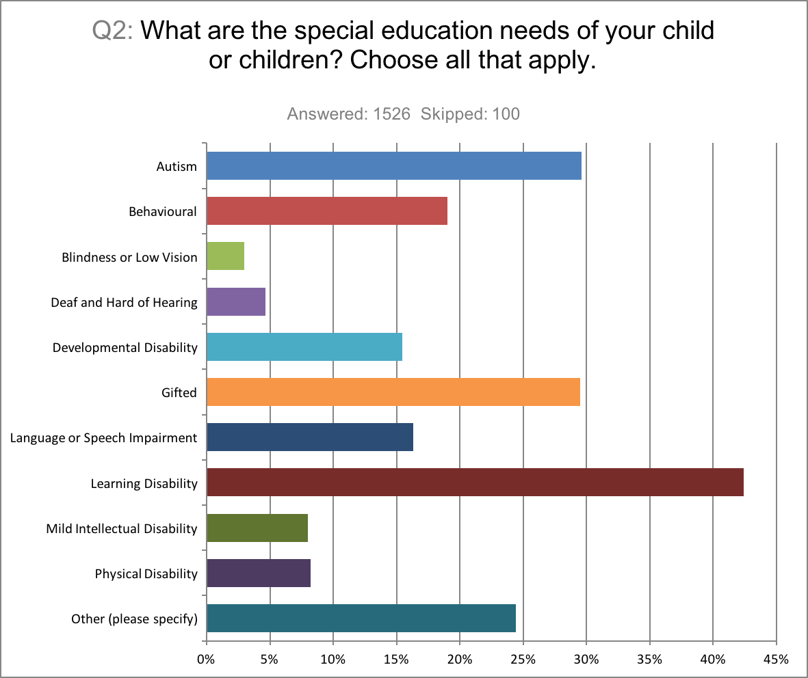

The responses revealed that the majority of children surveyed had either a learning disability (647), autism (452), or were gifted (450). Additionally, behavioural needs (290) and language or speech impairment (249) were also cited as significant special education needs of students.

Among the needs not listed in the survey, ADHD and Anxiety were most frequently mentioned by the respondents.

The data also reveals that many students have multiple needs that need to be addressed and cannot be readily separated into groups with singular needs.

SECTION C: EXPERIENCES WITH THE TDSB

Parents were asked to speak about their respective experiences in dealing with the Toronto District School Board. The questions in this section focused on the time when their child’s special needs were noticed, their knowledge of existing support systems for their child, and their overall satisfaction with the TDSB’s management of their child’s particular needs.

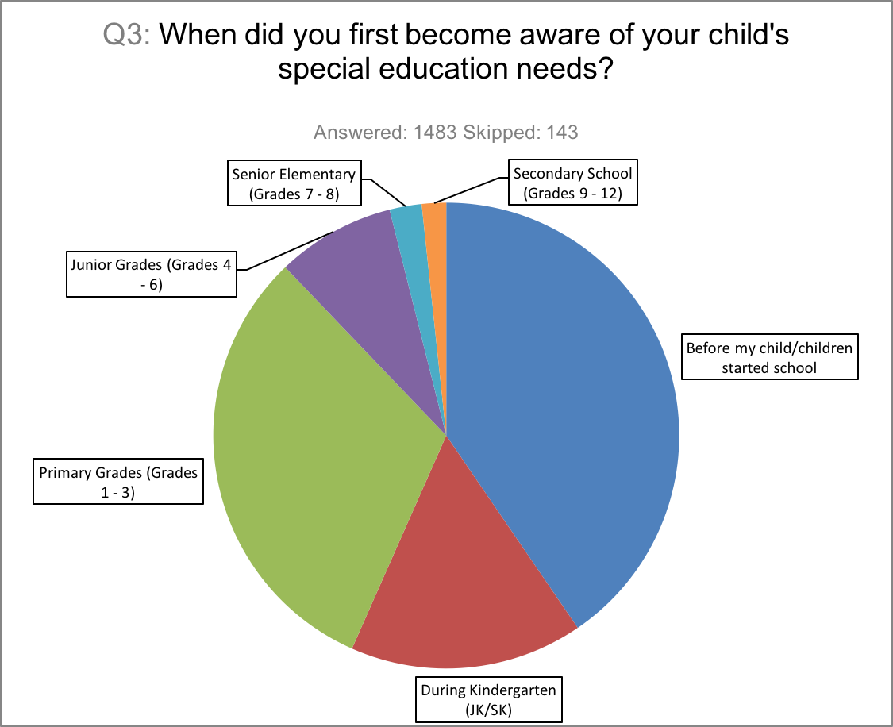

For 600 of the 1483 respondents, their child’s needs were known to them early on, prior to them starting school. For those that were identified later, the largest number of parents became aware of their child’s needs when they began Primary School, Grades 1-3 (463 respondents). The data would suggest that there should be more vigilance in the earlier classes so that these needs are identified at the earliest time of manifestation. A positive takeaway from this information is that the school administration can take a proactive role in reaching out to parents with special needs children prior to their enrollment and tailor their procedures to better cater to their needs.

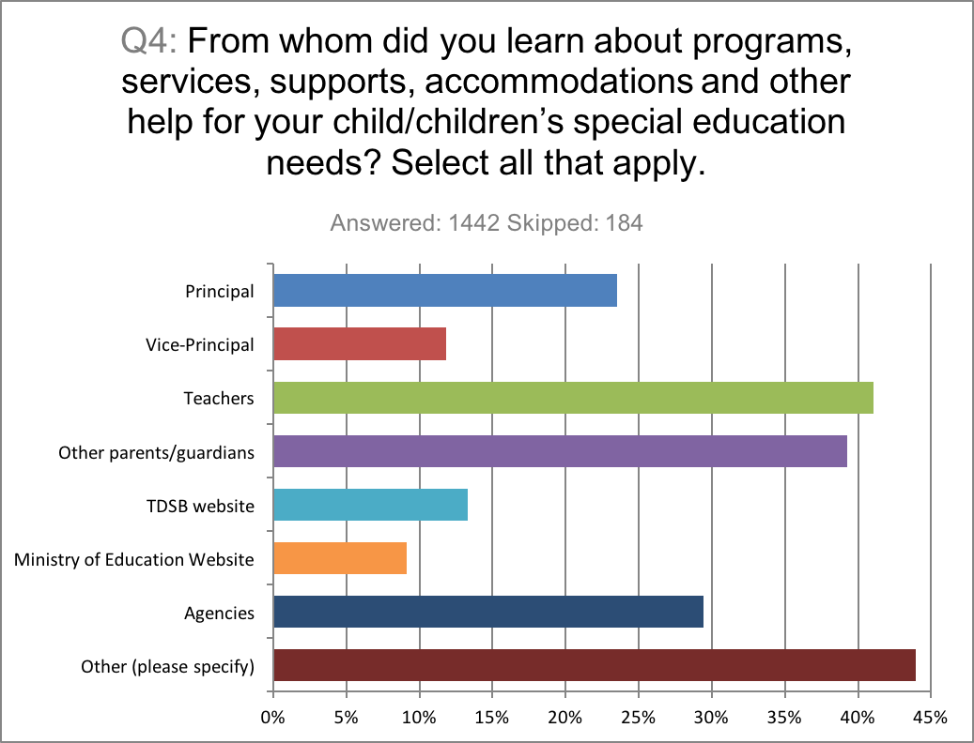

In terms of learning about programs for their children, teachers, and other parents were the most commonly mentioned source of information for the respondents.

The TDSB website and the Ministry of Education website received some of the lowest responses. A significant number of respondents commented that in order to learn about relevant programs and supports they had to conduct their own personal research. As such the TDSB and Ministry of Education websites should provide better information for parents on the available supports for their children.

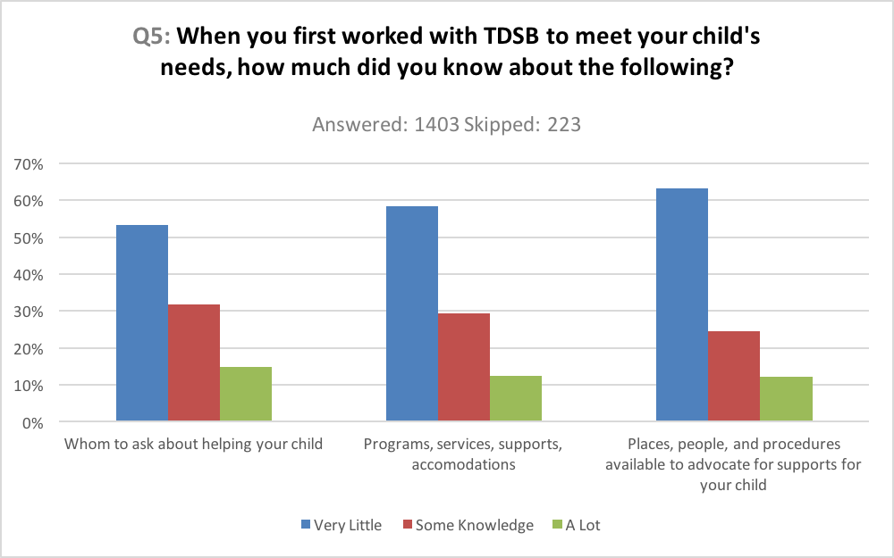

Parents were asked the extent to which they were familiar with the supports for special needs students. For each of the categories surveyed, “whom to ask about help”, “programs, services, supports” and “places, people and procedure for advocate for your child”, the majority of respondents had very little knowledge. The percentage of parents that were well informed was significantly low in each category (12-15%), highlighting the need for the TDSB to better communicate with such parents in advance of these needs arising. Additionally, in the additional comments, many respondents lamented the fact that they were often misguided or had their question unsatisfactorily answered by the school personnel and had to do their own research to learn more about accommodation.

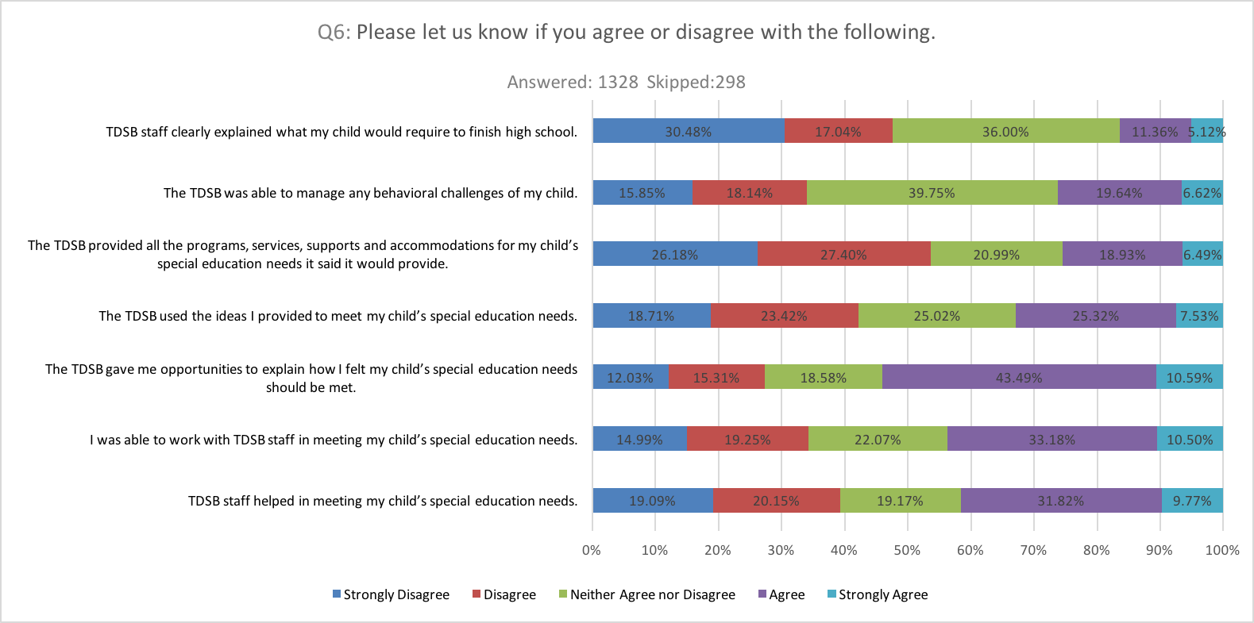

It is in response to questions about their overall satisfaction with the TDSB that some interesting insights can be drawn. Comparing the “Strongly Agree” and “Agree” and the “Strongly Disagree” and “Disagree” categories, we found that while several respondents were satisfied with their ability to work with TDSB staff and explain how their child’s needs should be met, they were not satisfied with TDSB’s ability to use those ideas and provides the supports they indicated they would. For example, 54% of parents responded with some level of agreement to the statement, “The TDSB gave me opportunities to explain how I felt my child’s special education needs should be met.” compared to 27% with dissatisfaction. However, 53.6% of parents reacted with dissatisfaction to the statement, “The TDSB provided all the programs, services, supports and accommodations for my child’s special education needs it said it would provide.” compared to 25.4% positively.

SECTION D: THE INDIVIDUAL EDUCATION PLAN (IEP)

This section deals with the Individual Education Plan (IEP), and asks parents to discuss their experience with their child’s IEP.
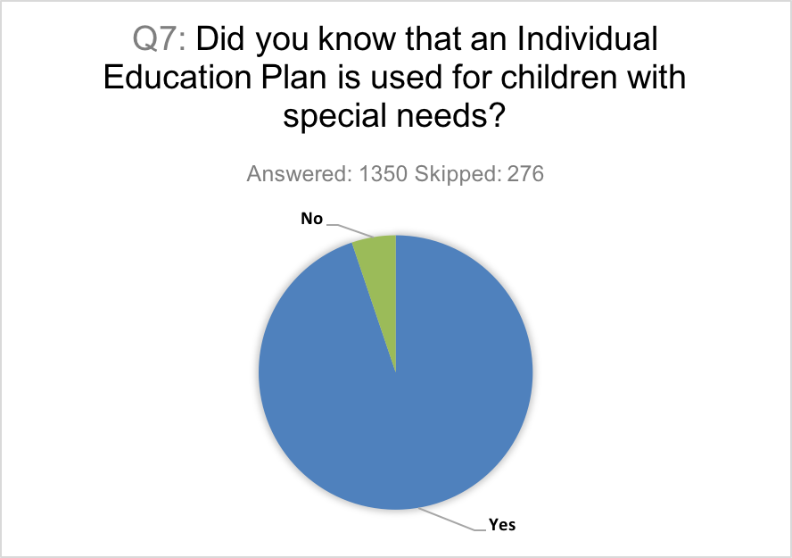

Of 1350 responses collected, 1280 parents (94.8%) indicated that they were aware that the IEP is used for children with special needs. When asked about whether or not their child has or at one point had an IEP, 88% of parents indicated that their child had an IEP.

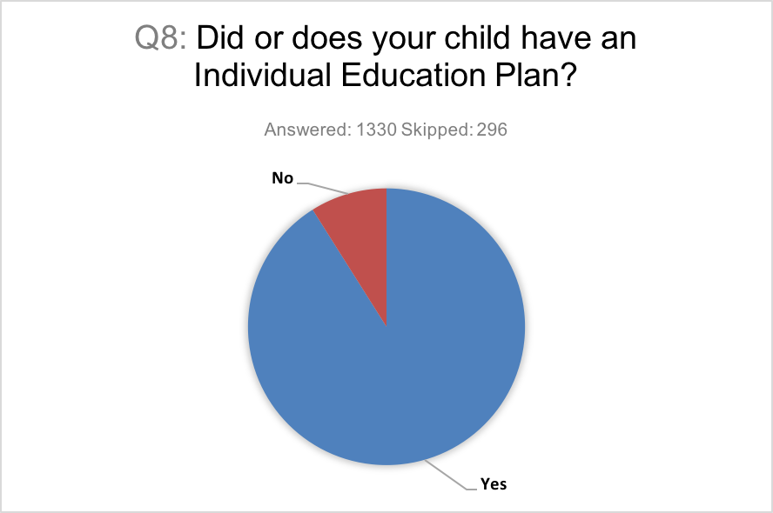

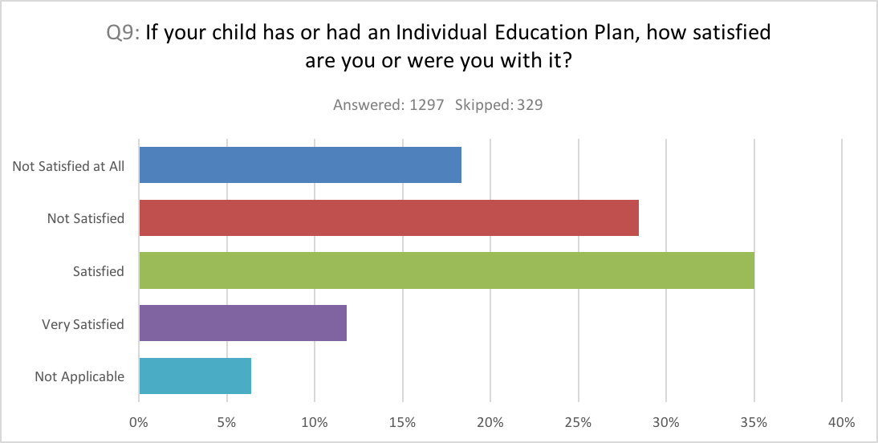

When asked about their level of satisfaction with their child’s IEP, the greatest individual response rate came from 454 (35.0%) parents, who indicated that they were “Satisfied” with their child’s IEP. Another 153 (11.8%) parents indicated that they were “Very Satisfied.” However, 369 (28.5%) parents indicated that they were “Not Satisfied,” with their child’s IEP, while 238 (18.4%) parents stated that they were “Not Satisfied at all.” Taken together, of those parents who responded to the question and found the question applicable, they were equally split on their impressions of the IEP. 46.8% of the total respondent parents expressed some sort of favourable view of their child’s IEP, and 46.8% expressed an unfavourable view.

Some of the comments from parents responding to this question suggest a wide spectrum of experiences and concerns. One of the most frequent concerns cited involved wait times. A number of respondents indicated that they had to wait (or are still waiting) lengthy periods of time to get an IEP for their child. One parent also noted that they did not have “a clear mechanism for measuring [their] child progress(regress) in place.” One parent noted that their child’s IEP was sometimes was used as a “weapon” by teachers to belittle them. For those parents that indicated that they were satisfied with their child’s IEP, a number of the respondents commented that their satisfaction was an eventual result, only after certain steps were taken to put the IEP into effect.

SECTION E: THE IPRC AND SEPRC
In this section, parents were asked to discuss their experiences with the Identification Placement Review Committee (IPRC) and/or the Special Education Placement Review Committee (SEPRC). Both of these committees make recommendations about what kind of placement a child should be in, i.e. a regular classroom or a special education classroom, or a combination of the two. The IPRC takes place upon enrollment and is established under the Education Act. The SEPRC takes place before enrollment and is a process established by TDSB itself.
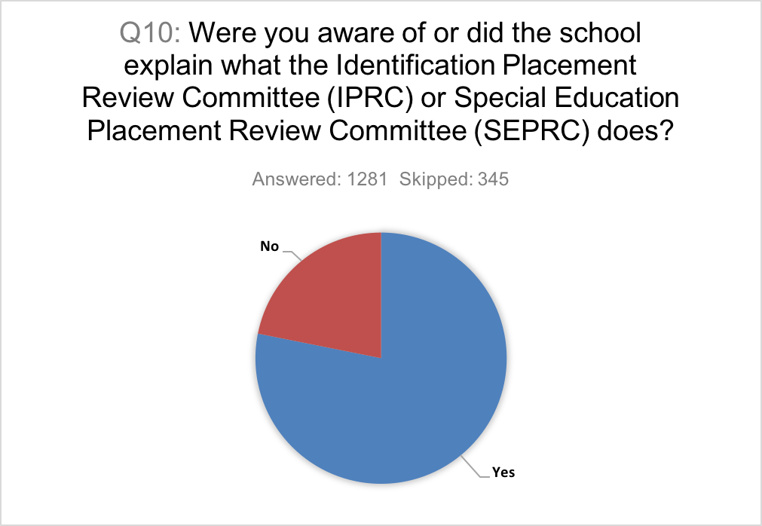

From 1281 responses collected, 1001 (78.1%) respondents indicated that they were aware of or had the school explain what these committees do. Conversely, 280 (21.9%) respondents indicated that they were not aware of these committees. However, some of the comments from parents suggest that, of the parents who were aware of the committees, many were not aware of the specific programs that each committee offers. A number of parents indicated that they had to do their own research to find out further information.

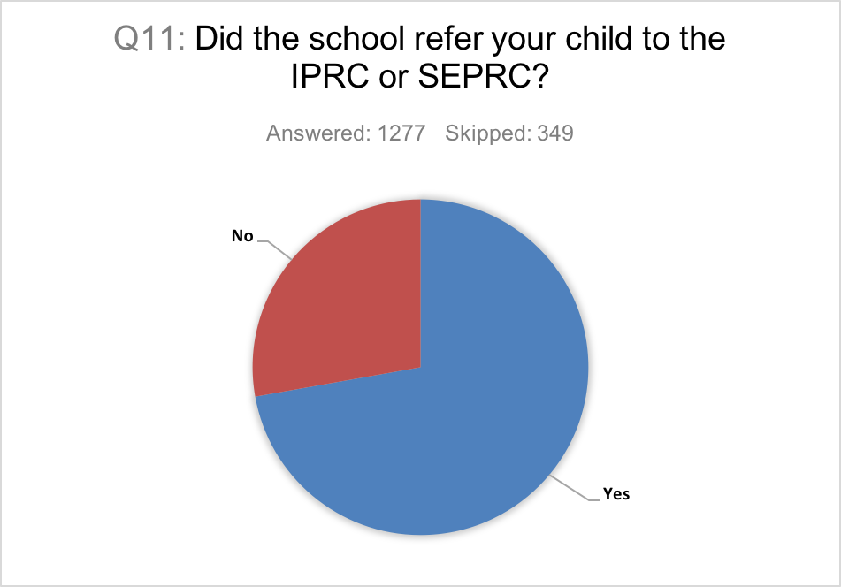

Of the 1277 responses collected, 922 (72.2%) of parents indicated that the school referred their child to the IRC or SEPRC. Conversely, 355 (27.8%) of parents indicated that they were not referred.

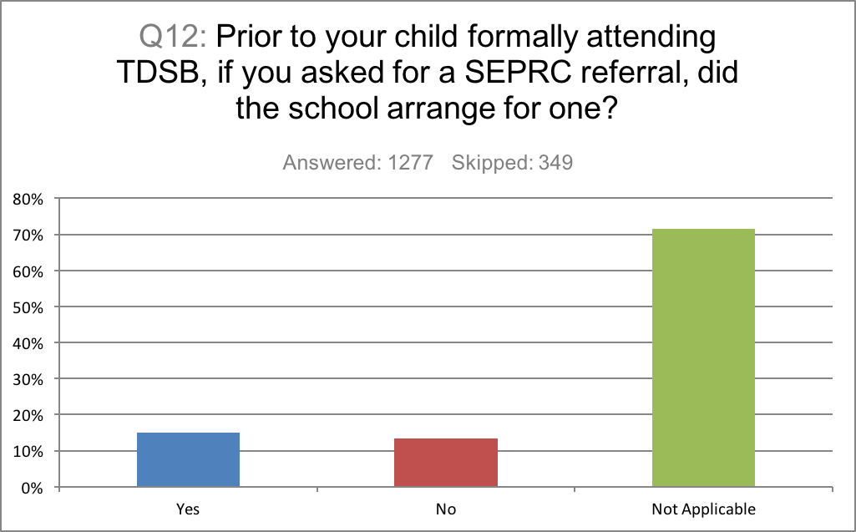

Parents were then asked about whether the school arranged for their child to receive an SEPRC referral following their request for one. Of the 1277 responses collected, only 363 responses were applicable. 193 parents indicated that the school had arranged for one, while 170 indicated that the school had not.

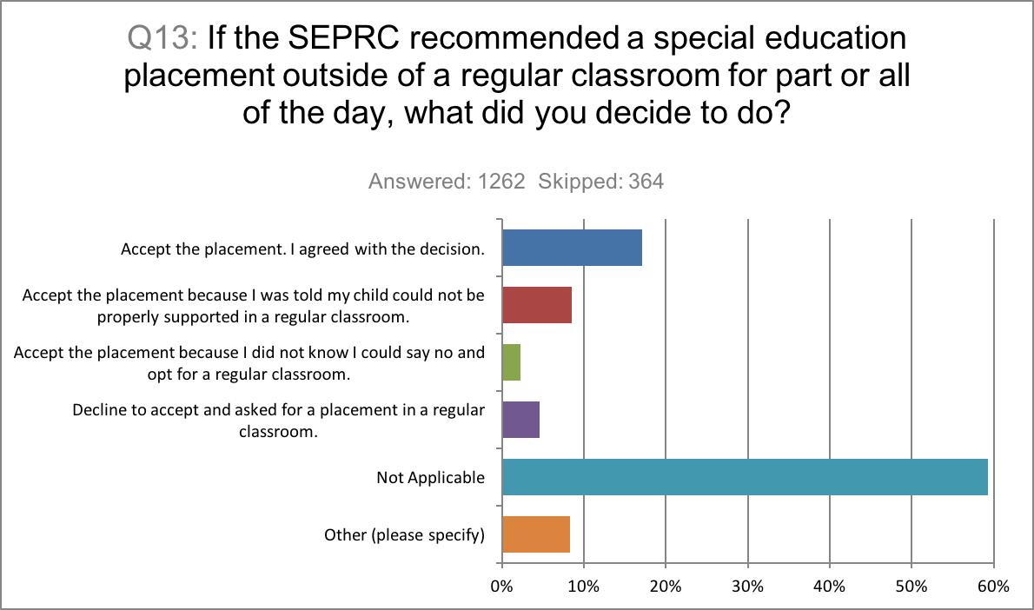

Parents were then asked about their various courses of action following a special education placement recommendations by the SEPRC. Of 514 applicable responses, 216 (42%) parents indicated that they accepted the placement, and agreed with the decision. 107 (20.8%) parents accepted the placement, but only because they were told their child could not be properly supported in a regular classroom. 28 (5%) parents accepted the placement, but only because they did not know they could say no and opt for a regular classroom. 58 (11%) parents declined to accept the placement and asked for a placement in a regular classroom. The remaining 105 (20.4%) parents indicated “Other” on the survey and provided additional responses. Some parents indicated that instead asked for blended learning, combining in-class and special needs teaching. Other parents noted their concerns about losing decision-making capacity with regards to the direction of their child’s education.

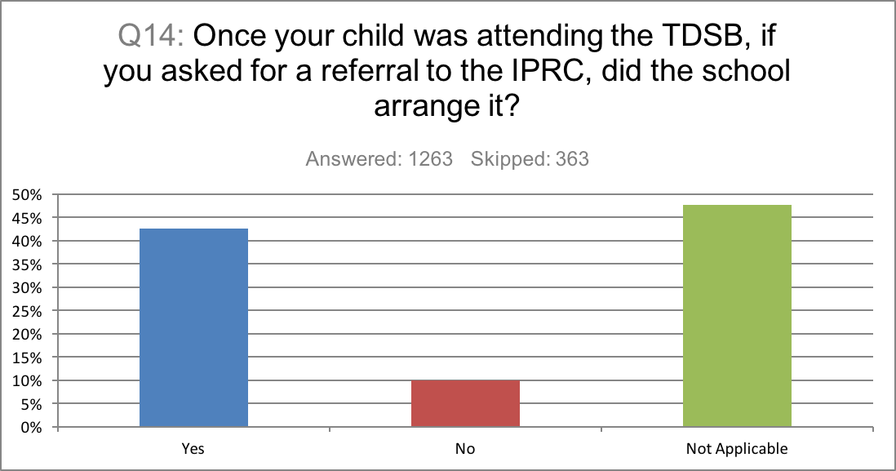

When asked about referrals to the IRPC in the TDSB, 1263 parents gave responses. Of those responses, 537 (42.5%) parents indicated that the school arranged the referrals, while 125 (9.9%) parents indicated that the school did not.

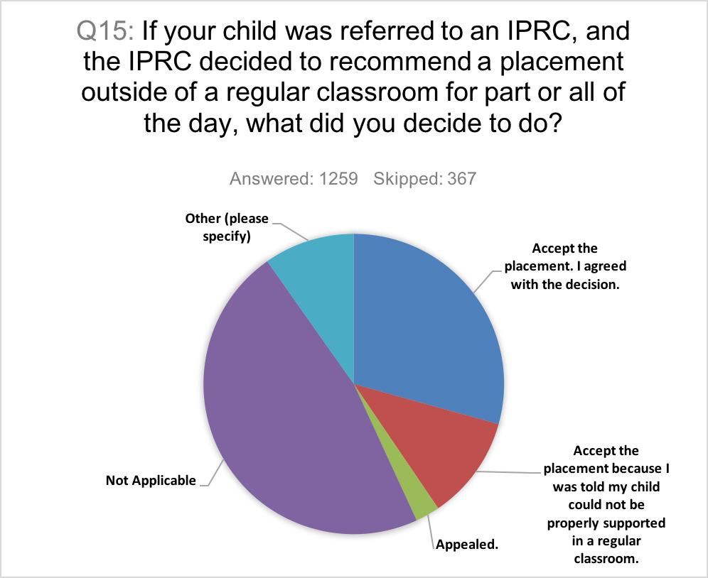

1259 parents responded to the question regarding courses of action following an IPRC recommendation for a placement outside of a regular classroom. Of those responses, 369 (29.3%) parents accepted the placement because they agreed with the IPRC decision. 141 (11.2%) parents accepted the placement because they were told their child could not be properly supported in a regular classroom. 33(2.6%) parents appealed the IPRC decision, and 123 (9.77%) parents took other courses of action, including declining the placement to keep the child in French immersion, keeping the child in the regular classroom, accepting the placement because of particular people (i.e. the principal) at the placement school, and accepting the placement because it was nearby.

The last question in the section asked parents to agree or disagree with the statement: “I was given enough information about services and programs available to students who are placed in 1) A regular classroom for the whole day; 2) A regular classroom for more than half of the instructional day and in a special education setting for the remainder of the day; and 3) A special education classroom for more than half or all of the instructional day.” 1217 parents submitted a response.
Below is a breakdown of the agreement or disagreement among parent respondents for each school setting type. Responses varied across the board, with slightly more parents agreeing that they received sufficient information about the regular classroom full-day option. The option with the least amount of agreement as to information having been provided was “the special education classroom for more than half or all of the instructional day” option. Overall, however, across all three categories, the percentage of parents that Strongly Disagreed or Disagreed with the statement was greater than the percentage of parents who Agreed or Strongly Agreed. This, along side the accompanying comments, demonstrates that schools and the TDSB can do a better job of communicating and sharing information with parents.

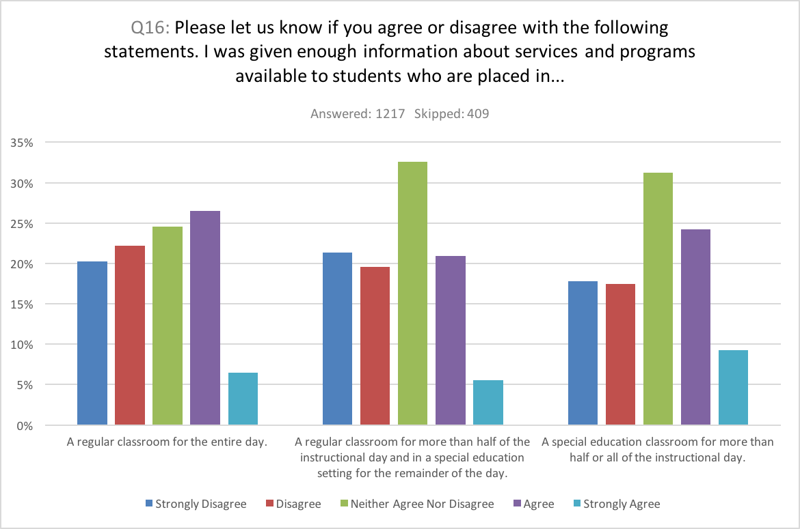

APPENDIX: ADDITIONAL COMMENTS AND TRENDS
In this section, we highlight some important trends and key quotations that were observed throughout the survey. In particular, questions 17 and 18 of the survey asked respondents to provide general comments and feedback on their IPRC or SEPRC experiences, as well as their experiences with special education programs more generally. Many of the responses to these questions are incorporated into the trends discussed below.
Trend #1: The Ongoing Fight Among Parents for Information and Services
Parents throughout expressed their dismay with the difficulties of seeking out more information and accountability for services offered. Below is a sample of quotations reflecting this theme:
“Where to begin...... It has been hard work as a parent. It is hard not to feel defensive and like you are battling the TDSB for your child. At the classroom and school level there have been some incredibly devoted and open teachers along the way. Overall I think that the expertise in misplaced in the school board and by that I mean that I believe parent should be seen and treated as the expert on their child. Too often the systems sets up the professionals within it to be the experts.”
“Takes a lot of fight, efforts, money to get the right information, services, placement for a child. A temporary solution of DFO (direct funding options) for families to find the appropriate education elsewhere or to home school could be an option till TDSB clears and fix the mess.”
“As a parent, I have been through a lot to fight for my child, and things are moving now, l have had many disappointments, but I always knew that I was on the right... Things have changed for my child, and are changing because I know that I have the support of the higher ups of the tdsb, education ministry and the government. My concern is that I shouldn't have to write to the director or the minister every time my child is denied her basic rights.... I appreciate this survey and the people at the board who want to make things better for all of us...”
“The process has been disempowering for parents and students. The system failed her. We approached the Superintendent last Spring - the 'team' assigned assured us that they would follow her progress from now on. Haven't heard from them. Lack of accountability is guaranteed. It has been exhausting!!”
“Everything is a struggle and fight. Parents with children without a disability are not subject to the intense advocacy skills needed to traverse the TDSB and get an education for their child. It is exhausting.”
“for the most part it has been a disaster I have spent so much time and energy advocating for both kids that I cant work getting them s.e.a claims was ridiculous....when it should have been so easy...it took forever and the special ed teacher had no clue what she was doing....totally pathetic she couldn't have been any more incompetent and she is still teaching ..lol.... so many kids lives she is damaging.... maybe someone can really see that she is not in the right position...she is the special ed mart at XXXXXXXXXXXX. Educate the principals... many don't have any idea what they are doing...and now ...we have one at the one school... who is highly knowledgeable ...who is fully supportive and has basically given us back part of our lives....just by doing her job well...she is the principal of XXXXXXXXXXXXXXXl. Get her to teach the other principals.. Our lives have been put on hold and ruined since our children entered school...it has been hell...and I would wish it on no one.”
Trend #2: Lack of Consistency among TDSB Staff
Parents repeatedly complained about the lack of care and effort among staff and administration. In addition, several parents complained about a lack of training or understanding among teachers when engaging and working with special needs children. On many occasions, decisions about placements for children were based on whether the staff at a given placement school actually cared about the child.
“There is no consistency across schools. Friends have had wonderful experiences. Some staff are incredibly knowledgeable and supportive. Our experience until grade five was awful. The only reason I did not file an official complaint was that I feared the staff would respond negatively and give my child even less support. Parents of special needs children are so dependent on the goodwill of school administrators that we have almost no power. It is an unconscionable situation that must be fixed. It breaks my heart to have to say this as a proud TDSB employee who works with many wonderful teachers and people in other supportive roles.”
“Staff and administration are not engaging transparently or authentically with families. They do not want to actively support children with special needs in a regular class setting and instead focus their efforts on trying to guilt the family to agree to a diagnostic placement. The teacher repeatedly telling the family she has 29 other children and is unable to spend time to assist in meeting the child's needs. The Principal not engaging the Board for other supports/ assessments to assist the teacher. These children are not appropriately being supported by the TDSB in a regular class placement.”
“Not good. I came very close to reporting one teacher, one principal, and the SE consultant to OCT. I was lied to many times over, hired advocates, a psychologist and a remedial teacher to do what should have been done automatically and with grace, professionalism and respect by the TDSB staff. At one point the superintendent of SE for TDSB became involved because of the many brick walls that my child was facing. This was ultimately helpful. Prior to this the local superintendent bullied me as well in response to my attempts to advocate for my child.”
“I would like to think that the most multi-cultural board in all of Canada does follow its Equity Policy. I think we are failing Spec. Ed. kids who are not seen as important in the eyes of many, from Admin. to teachers. TDSB needs to change that culture. There are Administrators promoting dumbing down of everything for these kids and that is not the way to go. These students are human beings with worth and value and intelligence but they don't get treated as such in many schools. Send out a survey to these kids, their parents, their teachers. The superintendent should visit schools and meet with Special Ed. staff . and teachers and find out the truth of what goes on. There is a lot more that TDSB can do and TDSB needs to make all parties accountable.”
Teachers who are consistent in their expectations and approach would benefit both students and parents. Often children with special needs require modified due dates, modified expectations and open and clear communication. Our experience has varied tremendously from year to year and this past year was a very frustrating one with no communication, due dates and assignments constantly changed and as a result it created a lot of anxiety and frustration. Students with special needs, in particular, benefit from clear expectations and guidance and not having that is detrimental to them and their experience in school.

Trend #3: IRPC and SEPRC Meetings are largely Inaccessible, Ineffective, and Infrequent
The large majority of respondents described negative experiences regarding their child’s IRPC / SEPRC meetings. Several respondents described the meetings as “stressful,” “scary,” “intimidating,” “cold,” and “uncaring.” There were, however, a few respondents who found the meetings to be clear, comfortable, and informative. A frequent concern raised was that parents felt that decisions regarding their child had been made prior to the meeting having taken place. Meetings were also arranged on short notice, and were far too short in length.
“Cold, uncaring, insensitive, rushed, bureaucratic, and over-staffed. There should be a system in place whereby: - parents/caregivers are able to view a realistic (but fictional) video so they have an idea what these meetings are like when they first attend - there should be a "mentoring" system via a "special ed council" (parents of special ed kids can accompany first timers to these meetings ) - there should be a feedback system whereby parents/caregivers can meet with administrators as a group, and make/receive suggestions for improvement of the system as a whole.”
“Schools are having IPRC's only once per year, mostly in May-June, doesn't matter when you request the meeting. If parents request the meeting, it should be clear that it's a case of emergency. We do not request a meeting for no reason.”
“We had only SEPRC so far. Our child is with ASD and non-verbal. On the placement meeting we were told that we are being send to classroom where the staff has experience working with kids with these needs. On the first meeting with the school staff that was confirmed : "Yes, we have experience with non-verbal kids" and with Autism. To our surprise we discovered very soon after the start of the school year (last year) that the knowledge about Autism is very minimal to the point that staff is not familiar even with the basic terminology. Also, there was no knowledge at all on the use of PECS and AAC and the iPad was not initially allowed as was considered a toy. We were wondering during the whole year why we were sent there and why such a misinformation. Speaking of that - using placements as a distribution of funds among schools should not be permitted and we would like to see consequences for the participants in such an actions. It's your job SEAC to stop this!”
“It was fairly clear that parents/caregivers who are uninformed, indifferent, or whom have barriers to advocating for their student would be at great disadvantage through the process. The panel format of the meetings is very intimidating, particularly if the parent/caregiver does not have an experienced trustworthy advocate with them for assistance or is unable to articulate their needs and concerns in that setting. It might be helpful to allow written submissions from all parties to consider in advance of the meetings.”
“Not enough notice / time to prepare for the meeting - feel like someone dropped the ball In our case somewhere since we only had two business days notice. The actual meetings are too short in time.... We felt rushed and ill prepared on what questions to ask etc.”
“The IPRC meeting provided us with clear information about the role of the committee and how the gifted program would be beneficial in supporting our daughter's needs. We felt confident about the choice we were making as a result of the information we received at this meeting .”
“IPRCs were always very stressful, we always felt out-numbered and that our role was to listen and agree. It was never entirely clear (or consistent) what we could and could not talk about. All too often we felt that the first concern was for the school and the teachers, with the educational needs of our child a secondary concern. Given the amount of influence and control the people on the other side of the table had over our son during his school day, we definitely felt it was necessary to be cautious in our comments and avoid criticism. I used to joke that I prepared more for an IPRC meeting that for the most important sales meetings of my business life. My husband and I would literally work out what we would and would not say, how we would indicate to each other if we felt things were getting difficult, and developed a strategy of asking for more than we wanted so that we could appear to concede when we were actually achieving our aims.”
“The experience was mostly positive. However I did not feel that the tdsb special education representative (not the teacher or principal) was advocating for my child. Fortunately I was comfortable in the meetings and had the support of the staff at my child's school. It would have been helpful to feel we could discuss all options.”
“It seemed that the principal had met with other meeting participants beforehand to come up with a plan of attack against me.”
“At no time during any IPRC meeting have I not felt intimidated or that the IPRC was truly impartial and acting in the best interests of our child. I am happy that managed to get into contact with an advocate so at least I know what the TDSB "should" be doing.”
“A 5 minute meeting to determine the needs of my child is not enough time. Placements are already decided before they even know my child. It's all based on spaces not best fit. The system is so flawed.”
“It is an awful experience. I feel like I have to face a firing squad at every meeting. I have to kick and scream and write letters to the special education superintendent to get heard. It's an exhausting process.”
Trend #4: The Mixed Response to Putting Children in Regular Classes
Parents had mixed feelings about having their children placed in regular classes. A relative majority of parents noted that regular classes are not equipped to give the special attention that children with special needs require. In particular, children with special needs who are gifted lose out. Nevertheless, some parents noted that special education classes were problematic and would have preferred full integration. In particular, special education classes isolated the children from the rest of the class and stunted their learning. In either case, parents noted that the individual needs of the child were being overlooked.
“How are regular classroom teachers suppose to accommodate special education learners with LD, MID, ADHD, anxiety, concussion, gifted, etc. in a classroom of 30 to 35 students. Really? It's no wonder that teachers get burned out so quickly. Let's remove all barriers so all students are the same and take class size into consideration when talking about supporting students with special education (anxiety, concussion, gifted, etc.).”
“Special education was terrible. My boys learned nothing but bad habits such as hitting and biting and. It did not help them one bit as the class looked like more like a babysitting place. Because TDSB has to full classes they out all kids from all different levels in the same class and it's a disaster. Within two weeks of removing them from special education class and putting green them in regular class all the hitting and biting stopped. Use of words soared and hundreds of new vocabularies was learn. So in my opinion special needs class is terrible. Kids should receive help in regular class setting as opposed to isolating them in special education.”
“There should be more schools that offer separate classes for disabled kids. Placing kids with development disabilities into classes with regular kids DOES NOT WORK. My son moved from regular class where he had a support worked to a special school and the change in his behavior is amazing. He is not as shy as he used to be and seems to be developing much faster. I believe the peer pressure of the abilities of regular kids mentally suppresses the kids with disabilities.”
“… My son is in a regular classroom but is painfully aware that his skills are not up to par. He has been called "stupid" and is regularly chosen last for groupwork. Luckily he makes friends easily - so he hates school time and lives for recess. My friend's son who has mild ASD is not so lucky. He's frustrated during class (as evidenced by multiple meltdowns), gets minimal work done, and is alone in the playground. For true "inclusion", there would have to be money to pay for someone to mentor him during outside time, help him regulate his emotions, and keep him attentive to school work. Right now he's just lost in the shuffle.”
“Phase out segregated classes ... my son's experience at the TDSB was a failure. He has proven he can learn in a regular class and the staff will acquire the skills necessary if you provide the training and expect them to accommodate.”
“Our experience prior to the full time special education class wasn't good. My child's needs were not, and I feel could not, be met in the regular classroom. Once she was properly placed she flourished. She started to like school, to feel better about herself, to make friends, to feel like she could learn and do well, to see a future.”
“I don't support the philosophy of full integration - the needs of the child with a learning disability often get overlooked in a regular class .”

